AVON

MGT 498 – 02

Spring 2012

Tyler Fluharty  
Graydon Henry  
Nate Gross  
Steve Gotses

**Table of Contents**

History and Overview……………………………………………………………………………………………………………………..page 3

Avon Vision Statement……………………………………………………………………………………………………………………page 5

Avon Mission Statement…………………………………………………………………………………………………………………page 5

Porter’s Five Forces Model……………………………………………………………………………………………………………..page 8

Rivals………………………………………………………………………………………………………………………………………………page 9

Finances………………………………………………………………………………………………………………………………………..page 11

Management/IS…………………………………………………………………………………………………………………………….page 23

Marketing……………………………………………………………………………………………………………………………………..page 26

SWOT Analysis………………………………………………………………………………………………………………………………page 30

IFE…………………………………………………………………………………………………………………………………………………page 34

EFE………………………………………………………………………………………………………………………………………………page 35

TOWS……………………………………………………………………………………………………………………………………………page 37

SPACE…………………………………………………………………………………………………………………………………..……….page 38

IE Matrix……………………………………………………………………………………………………………………………………..page 40

Conclusion…………………………………………………………………………………………………………………………...……….page 41

References…………………………………………………………………………………………………………………………………….page 42

Log……………………………………………………………………………………………………………………………………………….page 43

**History and Overview**

David H. McConnell, founder of AVON, was a travelling book salesman. He founded the company in 1886 after realizing his female customers were not as interested in his books as much as the free perfume samples he offered. This was during a time when husbands went off to work and left their wives isolated at home. Noticing this, he recruited females as sales representatives to sell his products. McConnell believed that women were naturally able to network and market to other women, and shared a passion for the products - originally perfumes. Employment opportunities for women were limited at that time, so the Avon earnings concept was revolutionary. This marked the beginning of the company’s long and rich history of empowering women around the globe.

In 1886, the idea of a woman running her own business was unheard of. Only about five million women were working outside of their home. The women that did work were confined to agriculture jobs, domestic service, and manufacturing. These types of jobs were notorious for hazardous working conditions and poor wages as compared to men. McConnell changed all of that by offering women the opportunity to create and manage their own business through what later became known as direct selling.

Avon was originally known as The California Perfume Company and changed its name to Avon Products Inc. after the British town Stratford-upon-Avon in 1938, birthplace of William Shakespeare. McConnell’s very first representative was Mrs. P.F.E Albee of New Hampshire. In just 13 shorts years the number of representatives grew to 5,000. As of its 2008 Annual Report, Avon has about 457,000 representatives in the United States alone. McConnell dedicated himself to ensuring the success of both his products and his employees. McConnell knew how to make sure employees were happy, motivated, and productive. He created a set of guiding principles that are still at the heart and spirit of Avon today.

These principles include:

* Providing an earnings opportunity so individuals can achieve financial independence and enjoy all that comes with such an accomplishment.
* Recognizing everyone's unique contributions.
* Giving back to the communities Avon serves.
* Offering the highest-quality products with a guarantee of satisfaction.
* Maintaining and cherishing the "friendly spirit of Avon.

Avon has evolved over the years from door-to-door direct selling to strangers, then to the workplace, colleagues, friends, and now online. The company has been through times of economic growth, world wars, and The Great Depression. It has stood the test of time because of the relationships built between representatives and the customers they serve. The direct selling approach has been tweaked over the years, and it still works today. In 1920, Avon sales topped $1 million. By 1972, the company reached $1 billion in sales. Finally, in 2008, the company pulled in $10 billion in sales. These figures would not have been possible without Avon’s five values that serve as sources of strength for the company. These values are:

* **Trust** means we want to live and work in an environment where communications are open—where people feel free to take risks, to share their points of view and to speak the truth as they see it. Trust people to do the right thing—and help them to understand your underlying reasoning and philosophy—and they won’t disappoint.
* **Respect** helps us to value differences, to appreciate each person for her or his unique qualities. Through respect, we help bring out the full potential of each person.
* **Belief** is the cornerstone of empowering associates to assume responsibilities and be the very best they can be. Believe in someone—and show it—and that person will move mountains to prove you’re right.
* **Humility** simply means we’re not always right—we don’t have all the answers—and we know it. We’re no less human than the people who work for us, and we’re not afraid to ask for help.
* **Integrity** should be the hallmark of every Avon associate. In setting and observing the highest ethical standards and doing the right thing, we fulfill a duty of care, not only to our Representatives and customers in the communities we serve, but to our colleagues and ourselves.

Avon’s history also reflects its current slogan – the company for women. The vision of Avon is “To be the company that best understands and satisfies the product, service and self-fulfillment needs of women - globally.” The company’s mission statement is composed of the following five parts:

* **The Global Beauty Leader**  
  We will build a unique portfolio of Beauty and related brands, striving to surpass our competitors in quality, innovation and value, and elevating our image to become the Beauty company most women turn to worldwide.
* **The Women's Choice for Buying**  
  We will become the destination store for women, offering the convenience of multiple brands and channels, and providing a personal high touch shopping experience that helps create lifelong customer relationships.
* **The Premier Direct Seller**We will expand our presence in direct selling and lead the reinvention of the channel, offering an entrepreneurial opportunity that delivers superior earnings, recognition, service and support, making it easy and rewarding to be affiliated with Avon and elevating the image of our industry.
* **The Best Place to Work**  
  We will be known for our leadership edge, through our passion for high standards, our respect for diversity and our commitment to create exceptional opportunities for professional growth so that associates can fulfill their highest potential.
* **The Largest Women's Foundation**  
  We will be a committed global champion for the health and well-being of women through philanthropic efforts that eliminate breast cancer from the face of the earth, and that empower women to achieve economic independence.
* **The Most Admired Company**We will deliver superior returns to our shareholders by tirelessly pursuing new growth opportunities while continually improving our profitability, a socially responsible, ethical company that is watched and emulated as a model of success

Avon currently has over 6.4 million representatives in over 100 countries. It is the world’s largest direct seller and leading beauty company. Avon has more than $11 billion in annual revenue. The company’s product line includes beauty, fashion and home products. Some of Avon’s well-recognized brand names include Avon Color, ANEW, Skin-So-Soft, Advance Techniques, Avon Naturals, and mark. Avon has more products that carry the name than any other brand in the world. Avon was the first beauty company to launch an e-commerce site, and is one of few companies that have been on the Fortune 500 list every year since the list’s inception.

Avon was ranked #16 in 2011 “100 Best Corporate Citizens List”. The list is one of the most prestigious and comprehensive rankings, examining the total scope of corporate responsibility efforts. Avon is committed to the mission to “do well by doing good.” The company’s corporate responsibility efforts focus on the empowerment of women, sustainability, and philanthropy. The company may be considered one of the world’s largest micro lenders, with $1 billion in credit extended virtually any day of the year, and about $4 billion annually in total Sales Representative earnings. Avon launched its Hello Green Tomorrow environmental stewardship internally in 2009, and externally in 2010 engaging Sales Representatives and customers worldwide. The mission of Hello Green Tomorrow is to mobilize a global environment movement to nurture nature and help end deforestation. Finally in 2007, actress Reese Witherspoon became honorary co-chair of the Avon Foundation. The Avon Foundation was founded in 1955 and is the largest corporate philanthropy dedicated to women’s causes globally. Its mission is both breast cancer research as well as access to care, and addressing domestic and gender violence. The foundation also responds to major global disasters such as the recent earthquake in Haiti.

Recently, Coty Inc., the world’s largest fragrance company, has expressed interest in acquiring Avon. Coty Inc. is a privately held company founded in Paris that engineers fragrances for such brands as Adidas, Playboy, and Calvin Klein. On April 16, 2012, Coty urged Avon shareholders to ask their company to give Coty a look at inside information, which would give the company the chance to offer its best price for Avon. Coty previously offered $10 billion for the company, which a spokeswoman for Avon said of the offer, "opportunistic and does not reflect the fundamental value of the company and its global beauty care and direct selling franchise." Avon also recently announced Johnson & Johnson senior executive Sherilyn McCoy as its new CEO, replacing charismatic chairman and CEO Andrea Jung as the company attempts to turn itself around. We’ll now look at the external environment outside of the news, with Porter’s Five Forces model.

**Porter’s Five Forces Model**

To begin assessing Avon’s external environment we’ll use Porter’s Five Forces Model of competitive analysis. This model is a widely used approach for developing strategies in many industries. The first force we’ll look at is rivalry among competing firms. Avon has a strong competitive advantage compared to its competitors in its exclusive direct-selling approach. In developing markets, this sales technique allows the company to quickly penetrate the market and access remote communities without a large capital investment. The company also has a continuous innovation initiative which analysts believe gives Avon a competitive advantage. Avon is a much older company than its competitors which has allowed it to build a relationship with customers that can’t be matched. Avon also receives numerous awards and recognition each year that differentiates itself from its competitors. For example, at the 2012 World Economic Forum in Davos, Avon was presented a spot in the top 25 Global Corporate Reputation Index. Another distinction the company earned was #47 of the 100 Most Innovative Companies. This was presented by Forbes in 2011.

The second force in Porter’s five forces model is the potential entry of new competitors. Avon and its competitors essentially manufacture and market cosmetic and beauty related products. This particular industry is not necessarily difficult to enter as Avon’s history can attest to. The industry is however very competitive and reaching brand recognition would be difficult for a new competitor. A strong marketing campaign would require a lot of capital and it would be difficult for a competitor without its own competitive advantage, whether it be less expensive products or better services.

The third force in Porter’s five forces model is the potential development of substitute products. In many industries this would be plastic container producers competing with glass and aluminum can producers. In the world of beauty, there are only so many compositions of chemicals that women will apply to their bodies. Avon certainly has competitors that produce similar products of various price ranges, but actual substitutes for make-up are limited. A recent substitute that has gained popularity is mineral makeup, although this is typically sold by the same manufacturers as traditional makeup, therefore not a substitute that would affect consumer’s switching costs.

The fourth force in Porter’s five forces model is the bargaining power of suppliers. In this industry, I would say that suppliers have little to no power. In Avon’s case, they own and operate their own manufacturing plants all around the world. Raw materials in this industry are not particularly hard to come by, therefore the suppliers have little bargaining power. Also, Avon is a huge company with great influence over its suppliers.

Finally, the fifth force in Porter’s five forces model is the bargaining power of consumers. This force is where Avon can get into some trouble because consumers have the choice to purchase their cosmetic needs from retail stores such as Wal-Mart or directly from the manufacturer. With the current state of the economy, consumers may be more interested in getting the best bang for their buck as compared to staying loyal to their sales representative. The bargaining power of consumers is higher when products being purchased are standard or undifferentiated. In this industry, you can contend that there is not a huge difference in makeup, coupled with the consumer’s ability to inexpensively switch from one brand to another. It’s vital for Avon to continue to innovate and create new products that would keep consumers from switching to a competitor.

**Rivals**

Avon faces stiff competition in the cosmetic industry. Their direct selling approach has made their products seem genuine and unlike other over the counter cosmetics. As far as main competitors go in the cosmetic industry, it would be important to be aware of Mary Kay and Revlon. Avon, in terms of revenues and marketing, currently dominate Mary Kay and Revlon but should be aware of the companies as they continue to grow.

Mary Kay, also a direct seller, was once viewed as “more of a middle-aged makeup,” said Kristin Finan, a 21-year-old University of Texas student. Ever since Mary Kay surveyed for public opinion, they have taken an aggressive stance on renovating their products into a more youthful look. They have targeted their advertisements in youth magazines and are now a huge competitor against the global market leader in Avon. They are a highly motivated sales force that replicates the sale strategies as Avon does.

Revlon, which does sell its products in department stores, is a considered a particularly dangerous competitor to Avon. They promote their products regularly through couponing and are sold in department stores such as JC Penny. Their brand continues to become more prestigious through advertising and their product line has been targeting women of all ages. Revlon is the second largest color cosmetics company in the US. Competitors Estee Lauder and Avon get the majority of their revenue outside the US.

Provided below is a pie chart of sales by Avon and their rival companies addressed above. This is to give you an idea of how much bigger Avon is compared to its competitors.

Sales in 2009: Avon: 10.2B Mary Kay: 2.5B Revlon: 1.30B

**Finances**

Financially, Avon has been a strong company over the years, with some struggles as of late. The company trades on the New York Stock Exchange under the ticker symbol AVP. According to Yahoo Finance, Avon is in the consumer goods sector of the personal products industry. This industry includes such competitors as L’Oreal SA, Revlon, Inc., and Mary Kay Inc. (privately held). Some basics of Avon’s financials include the following: Avon’s 52wk range is between $16.09 and $31.60/share. The stock is currently trading at $22.55/share. Avon has a market capitalization of 9.72B. The company’s P/E (ttm) is 19.11 and its EPS is 1.18. The company pays a quarterly $0.92 dividend with a 3.90% yield.

Avon Products was recently upgraded by TheStreet Ratings from a hold to a buy stock. TheStreet reports that the company’s strengths can be seen in multiple areas such as its attractive valuation levels, expanding profit margins, and good cash flow from operations. Although the company has had subpar growth in net income, it’s still a valuable stock. The company’s gross profit margin for Q4 2011 is essentially the same as it was a year prior although sales and net income have dropped. Net income dropped from 228.8M in Q4 FY10 to -1.3M in Q4 FY11. Net sales dropped from 3175.6M in Q4 FY10 to 3043.7M in Q4 FY11. Net operating cash flow has increased $421.60 million or 15.82% compared to the same quarter of the previous year. Avon has a relatively high gross profit margin at 63.40% although it’s a decrease from last year. These are only quarterly comparisons. We’ll look at annual comparisons in the income statement, balance sheet, and statement of cash flows below. Finally, over the past few years the company has seen a decline in annual earnings per share reporting $1.20 as compared to $1.36 of the year before. Estimates for this year’s EPS indicate a reversal of that trend, at $1.49 per share. This increase would indicate the company may be more profitable this year.

Over the past two years the company’s stock price has fluctuated from lows of 16.09 to highs of 35.49. Below is a graph that depicts some of the major drops and surges in price and some of the headlines that caused these.

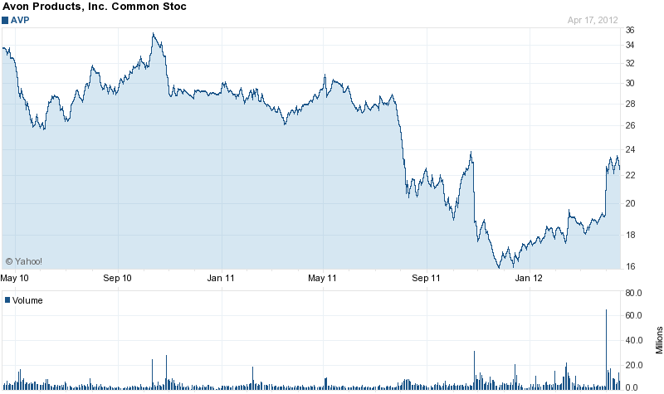

The most recent surge in stock price was on April 2, 2012 as beauty and fragrance company Coty offered to acquire Avon for $10 billion. This shot up the company’s stock to 22.70 or 17.25% from the previous close. Avon rejected the bid. On Feb 14, 2012 Avon Products reported weaker-than-expected fourth-quarter results as sales declined in most markets. Avon sales representatives also decreased by three percent, in which a Morgan Stanley analyst said was the worst drop in more than a decade. The following graph shows the percentage change in revenues and sales representatives as well as a comparison between net income and share price.

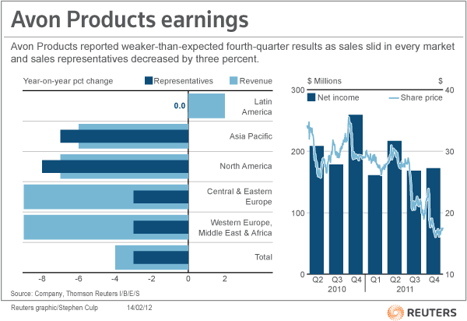

Avon’s sales have been struggling in the last year in important emerging markets such as Brazil and Russia. The company was banking on these markets to offset its long-term slide in North America. Revenue fell 1 percent in Brazil due to poor implementation of a new computer system, which frustrated sales representatives. Avon competes with Brazil’s own Natura Cosmetics SA in that market as well. In Russia, revenue fell 10 percent where competitors were beating Avon in pricing and sales representatives. In Mexico however, sales were up 12 percent. Ex-CEO Andrea Jung said that the focus in 2012 would be sales improvements and containing costs, rather than improvement in margins. Another sharp drop in Avon’s share price came in October after the company reported a net income decline and that U.S. regulators were investigating its contact with financial analysts. The company’s stock dropped 18% in their biggest percentage plunge at least 10 years. The company was and is still being investigated for possible violations of the Foreign Corrupt Practices Act. Avon launched an internal ethics review and contacted the SEC and DOJ in 2008 regarding reports of bribes in China. In 2005, China ended a seven-year ban on direct selling by allowing Avon to be the first Western company licensed to sell products door-to-door.

Next, we’ll look at some of Avon’s financial statements, beginning with the income statement below. Using the income statement, financial performance is assessed by giving a summary of how the business incurs its revenues and expenses through both operating and non-operating activities.

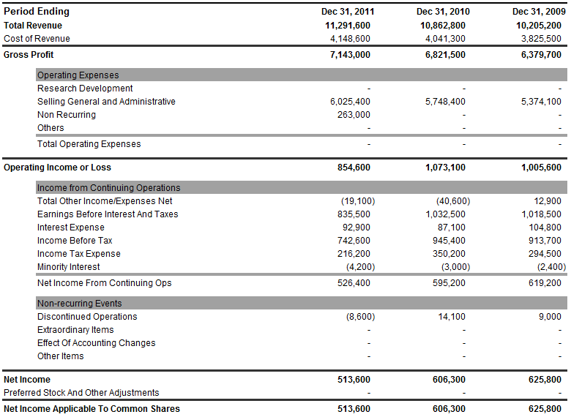

Avon’s Total Revenue has grown over the past three years, although the company’s bottom line has been shrinking. Avon’s total revenue has grown from 10.205B in 2009 to 11.291B in 2011. Its cost of revenue has been mostly unchanged although its selling general and administrative expenses have grown. This increase in the percentage of sales devoted to SGA costs from 52.90% to 53.97% was likely a key contributor to the decline in net income. The increase in SGA costs is also primarily due to the company’s continued investment in RVP, as well as higher distribution costs and bad debt expense. The company’s operating income has dropped in 2011 likely due to a decrease in earnings (EBIT).

Below is the balance sheet for the past three years. The balance sheet gives investors an idea as to what the company owns and owes, as well as the amount invested by shareholders.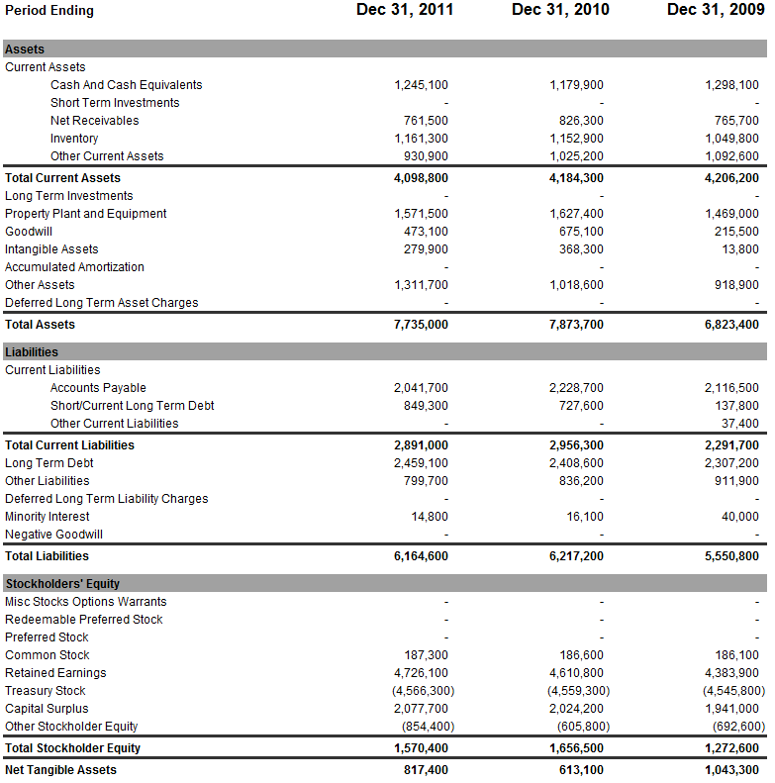

Avon’s total assets have shrunk slightly in 2011, at 7.735B compared to 2010 at 7.873B. This can be attributed to a decline in net receivables, other current assets, property plant and equipment, goodwill, as well as intangible assets. The company’s total liabilities have also slightly decreased between 2010 and 2011. Most changes in liabilities are minimal between the years. Finally, Avon’s total stockholder equity has decreased to 1.570B in 2011 from 1.656B in 2010. This is most likely caused by the increase in negative other stockholder equity. Interestingly, Avon’s common stock has risen 500 shares from 2009 to 2010, and 700 shares from 2010 to 2011.

Below is the statement of cash flows for Avon. This document provides aggregate data regarding all cash inflows a company receives from both its ongoing operations and external investment sources, as well as all cash outflows that pay for business activities and investments during a given quarter.

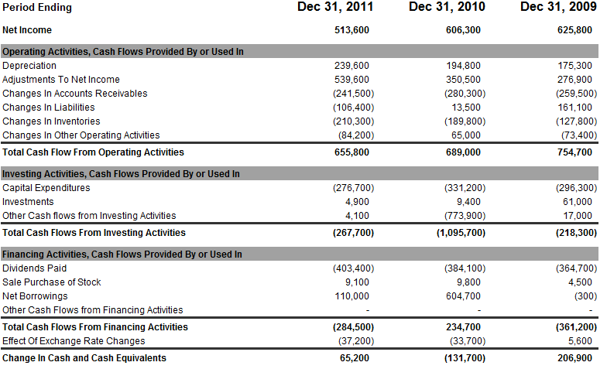

Some points to note here is the increase in dividends paid in 2011 from the previous years as well as strong changes in figures such as net borrowings and other cash flows from investing activities. From this you’re able to see that Avon is able to manage their cash flows effectively.

Below are some important financial ratios for the company. These ratios are taken from Reuters and compared to the industry. 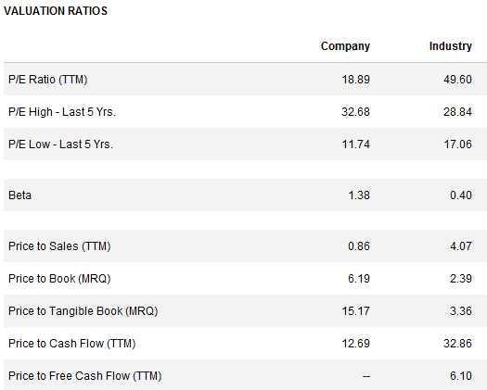

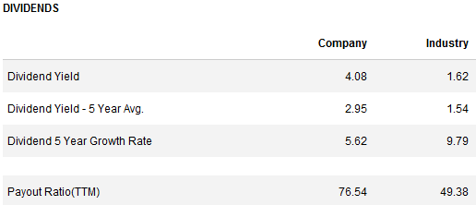 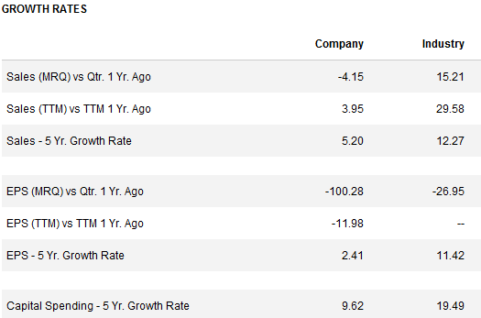 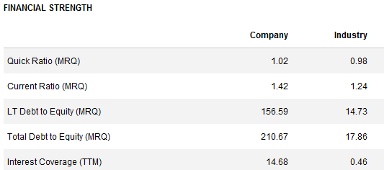

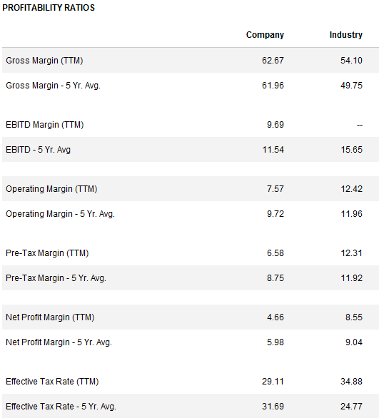

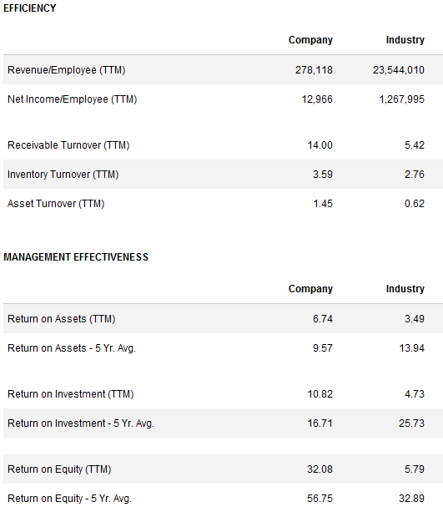

Some ratios are more important than others in assessing the company. First we’ll look at measures of liquidity which is the firm’s ability to meet its day-to-day operating expenses and satisfy its short-term obligations as they come due. Current ratio and net working capital are two measures to look at.  
The current ratio of Avon is 1.42. This can be interpreted as Avon having $1.42 in short-term resources for each dollar of current debt. Avon is above the industry average of 1.24, therefore would be able to pay off its short-term debts more capably than its peers. Net working capital is a measure of company’s efficiency and its short-term financial health. The formula is current assets minus current liabilities. In Avon’s case (in thousands), this would be 7,735,000 – 6,164,600 = 1,570,400, therefore Avon is very efficient in this respect.

Other ratios to consider include the P/E ratio, gross profit margin, asset turnover, and dividend yield. Avon has P/E ratio of 18.89 compared to the industry average of 49.60. The P/E ratio determines how “cheap” or “expensive” a stock is. Avon’s gross profit margin is 62.67 compared to the industry average of 54.10. This lets us know how much money is left over after accounting for cost of goods sold. Avon is higher than the industry average, therefore a more efficient company. Asset turnover is the amount of sales generated for every dollar’s worth of assets. This measures a firm’s efficiency at using its assets to generate revenue. Avon’s asset turnover is 6.74 compared to the industry average of 3.49. Again, Avon is efficient in the use of its assets. Finally, the dividend yield is a measure of how much a company pays out in dividends each year relative to its share price. Avon has a dividend yield of 4.08 compared to the industry average of 1.62. Avon pays a relatively high dividend to attract investors over its competitors. Financially, Avon has struggled in the last few quarters although overall it appears to be a relatively stable company.

**Management/IS**

Avon’s executive leadership consists of the following individuals.

1. Newly appointed Sherilyn McCoy of Johnson & Johnson - Chief Executive Officer  
2. Charles M. Herington - Executive Vice President, Developing Market Group  
3. Kimberly A. Ross - Executive Vice President and Chief Financial Officer  
4. Fernando J. Acosta - Senior Vice President & President, Latin America   
5. Lucien Alziari - Senior Vice President, Human Resources & Corporate Responsibility  
6. Bob Briddon - Senior Vice President & President, Asia Pacific  
7. Nancy Glaser - Senior Vice President, Global Communications  
8. Donagh Herlihy - Senior Vice President, Chief Information Officer & eCommerce  
9. John Higson - Senior Vice President & President, Europe, Middle East & Africa  
10. Jorge Martinez Quiroga - Senior Vice President & President, North America  
11. Anna Segatti - Senior Vice President, Global Commercial Operations  
12. John F. Owen - Senior Vice President, Global Supply Chain  
13. Kim Rucker - Senior Vice President, General Counsel, Corporate Secretary and Chief Compliance Officer  
14. Mike Schwartz - Senior Vice President, Global Insights & Marketing Intelligence

As mentioned, Avon recently announced a new CEO to replace Andrea Jung, who was under fire for failing to curb the company’s financial declines at home, and in key markets such as Brazil and Russia. Jung was also criticized for not wrapping up the on-going bribery investigation in a timely manner, which has damaged the company’s reputation. Andrea Jung will remain executive chairman after Sherilyn McCoy takes over on April 23, 2012. Some of Avon’s recent managerial struggles include the declining in North American sales and the shift to over 80% of Avon’s $11 billion in annual revenue coming from foreign markets. The company has also been frequently missing analysts’ expected earnings. McCoy, a Princeton graduate, is expected to be the new direction for Avon in the coming months. Fred Hassan, lead director of Avon’s board said of McCoy, “Sheri has a unique combination of strategic and finely-honed operational skills, a significant turnaround track record, global experience and people leadership.” Many shareholders said they are prepared to give McCoy the time she needs to develop and implement a new strategy for Avon. "Until we have a better sense of her, we'll give her time to develop a strategy," said Shawn Gault, a portfolio manager at Kempner Capital Management Inc. Avon has attempted over the years to institute restructuring plans with little success under Jung.

One of such strategies was a multi-year restructuring plan developed in 2005 in an effort to drive revenue and profit growth. This plan consisted of reorganizing and downsizing the company, implementing manufacturing on a global scale, and increasing the efficiency of supply chains. The company expected the restructuring to help increase funding for consumer research, marketing, and product development. They had also hoped this would enhance sales and profits. By mid-2006, the company saw an improvement in year-to-year sales growth rate, but the savings from the plan were not substantial enough to counter the increase in expenses.

In 2005, Avon also started the implementation of a global supply chain strategy which included the development of new common systems platform known as enterprise resource planning or ERP. ERP is business management software that allows an organization to use a system of integrated applications to manage the business. Avon has recently had some struggles with its Oracle ERP suite in Brazil. The implementation of the new system was postponed five or six times before its completion in July. The troubles caused a large number of IT staff to leave the company over the last 18 months.

In February 2009, Avon announced a new restructuring program to be fully implemented by 2012 or 2013. This restructuring plan was to focus on the reorganization of its global supply chain operations, realignment of local business support functions to a more regional basis to drive increased efficiencies, and the streamlining of transaction-related services. This includes selective outsourcing and reorganizing other miscellaneous functions. The company expects to incur costs of this program to be between $300 and $310 million before taxes. The company hopes this plan will save approximately $200 million per year after full implementation. Avon may implement a new restructuring plan under McCoy in the near future, to offset some of the disappointing results of the 2005 plan.

**Marketing**

Avon follows a multi-level marketing approach and is one of the most successful MLM companies in the U.S. MLM is a type of network marketing where the foundation is built on the concept of direct sales. Direct sales is a retail sales model in which a company sells its products and services through a distribution channel made up of independent distributers or business owners. Avon uses direct selling as well as catalogs and the internet to sell its products. Each Avon distributer is provided with the Avon business website where guests can place orders, which makes the sales process a fairly simple and pleasurable experience for the customer. One downside to these business websites though is that they are virtually identical to one another with minimal personalization options. Avon agents use the following strategies to attract new customers and build relationships with customers.

Avon representatives are able to advertise in popular local businesses to reach a larger customer base. They do this by delivering products ordered online to local businesses such as coffee shops and book stores. This allows customers to save on shipping costs and encourages them to purchase more products. Avon reps will arrange part of their commission to be paid to these businesses that agree to store and distribute Avon’s products alongside their normal business operations.

Another marketing strategy, which is one of the most popular and cost effective strategies is internet marketing. Avon representatives are able to get their name out by a multitude of channels such as social media like Facebook and informative article websites like ezinearticles.com. Avon reps will post links to their Avon business website to increase sales and exposure.

Avon representative’s success is dependent on their ability to network and connect with individuals. Some reps will connect with employees of large local businesses enabling them to sell and advertise their products to a larger target audience. Avon reps will provide support material such as catalogs throughout these organizations in which interested persons can place orders through. In such cases, many employees will get together to purchase in volume which allows the agents to receive discounts and take in a greater portion of profits. These are just some ways Avon reps market to their customers but from a corporate standpoint, the company markets in a different way.

Avon used to market exclusively to women and still does to an extent. After all, it is the *company for woman*. The company has recently moved into developing products for men and children. This includes such products as colognes for men and bath bubbles for children. Because Avon has the reputation of selling products only to women, they have had to incur some advertising costs to push these new markets. In 2011, Avon significantly increased spending on advertising over the four years leading up to it. Advertising is a key strategy to the company and increase in costs has supported new product launches such as Outspoken Intense by Fergie Fragrance and Anew Solar Advance Sunscreen Face Lotion. The company also continues to invest in its direct-selling channel to reward its representatives and entice more to join the company. During 2011, Avon invested approximately $121.0M in its representatives through its Representative Value Proposition. This was accomplished through continued implementation of its Sales Leadership program, enhanced incentives, and increased sales campaign frequency, improved commissions and new e-business tools. The company continues to improve internet-based tools for its representatives worldwide.

Avon markets to women in more than 100 countries through its approximately 6.4 million active Avon sales representatives. Below is a map that depicts the various markets Avon currently does business in.

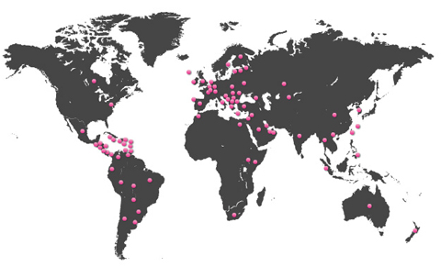

A complete list of these markets is below.

|  |  |  |  |  |  |
| --- | --- | --- | --- | --- | --- |
| **Markets** | *Bolivia* | *Cyprus* | *Grand Cayman Island* | *Jamaica* | *Malta* |
| *Albania* | *Bonaire* | *Czech* | *Greece* | *Jordan* | *Mauritius* |
| *Antigua and Barbuda* | *Bosnia* | *Dominica* | *Grenada* | *Kazakhstan* | *Mexico* |
| *Argentina* | *Brazil* | *Dominican Republic* | *Guatemala* | *Korea* | *Moldova* |
| *Armenia* | *Bulgaria* | *Ecuador* | *Guyana* | *Kuwait* | *Mongolia* |
| *Aruba* | *Canada* | *Egypt* | *Honduras* | *Kyrgyzstan* | *Montenegro* |
| *Australia* | *Chile* | *El Salvador* | *Hong Kong* | *Latvia* | *Morocco* |
| *Bahamas* | *China* | *Estonia* | *Hungary* | *Lebanon* | *Mozambique* |
| *Barbados* | *Colombia* | *Finland* | *Iceland* | *Lesotho* | *Namibia* |
| *Belarus* | *Costa Rica* | *France* | *India* | *Lithuania* | *New Zealand* |
| *Belize* | *Croatia* | *Georgia* | *Ireland* | *Macedonia* | *Nicaragua* |
| *Bermuda* | *Curacao* | *Germany* | *Italy* | *Malaysia* | *North Cyprus* |
| *Saudi Arabia* | *Suriname* | *United States* |
| *Serbia* | *Taiwan* | *Uruguay* |
| *Slovakia* | *Thailand* | *Venezuela* |
| *Slovenia* | *Tortola* | *Vietnam* |
| *South Africa* | *Trinidad & Tobago* | *Virgin Islands* |
| *South Africa – Justine* | *Tunisia* | *Zambia* |
| *Spain* | *Turkey* |
| *St. Croix* | *Turkmenistan* |
| *St. Kitts & Nevis* | *Turks & Caicaos* |
| *St. Lucia* | *UAE* |
| *St. Maarten* | *Ukraine* |
| *St. Thomas* | *United Kingdom* |

In 2009 the company incurred some additional advertising costs when it ran at ad during the Super Bowl that year. The ad was not designed to promote any of the company’s products but rather to recruit additional representatives for the company. I don’t particularly agree with an ad during the Super Bowl, a predominately male audience for a cosmetics company but nonetheless the ad did increase the number of Avon reps. The recession hit during this time so it was a good opportunity for housewives that may have lost their jobs to bring in extra income for the year. Next we’re going to look at some different models beginning with the SWOT analysis.

A SWOT analysis is a strategic planning method used to evaluate the **s**trengths, **w**eaknesses, **o**pportunities, and **t**hreats of an organization. Below is the SWOT analysis for Avon Products Inc.

**Strengths**

1. World’s largest direct seller – Strength in numbers.

2. Total revenue has increased over $420 million since 2010 – Rising revenues indicate a growth in sales.

3. Recipient of multiple global awards and recognition – Avon strives to be an industry leader in many facets of corporate responsibility. These recognitions give the company a good image and should entice investors.

4. Avon global philanthropy donated more than $860 million to date – Core to Avon’s mission and important part of the company’s “DNA”. Charitable companies are perceived well by customers and give them another reason to purchase their products.

5. Over a 90% brand recognition in most major markets - Brand recognition is vital when moving into new markets and not being an unheard of company.

6. First beauty company to launch an e-commerce site – Staying ahead of the pack from a technology standpoint is always a good thing. This gives them an edge over their competitors which would have had a later start in the e-commerce industry.

7. Listed on Fortune 500 every year since the list’s inception – A recognition shared with only a handful of companies. This indicates the company has become experienced over the years.

**Weaknesses**

1. Low brand image – Avon has a low brand image because they have so many products that don’t always carry the Avon name. It may be difficult for customers that are unfamiliar with Avon’s products to distinguish them.

2. Sales less personal with e-commerce – Sales representatives have customers purchase through their Avon business site and may never even meet the customer. This ruins the personal, door-to-door selling aspect which is the core of the company.

3. Questionable ethics regarding bribery – Avon is currently being investigated for bribing Chinese officials to secure a door-to-door sales license in that country. This negatively impacts the company’s image.

4. Shrinking revenue in North American markets – The company is struggling in its home market of North America. About 80% of Avon’s 11B in annual revenue comes from overseas.

5. Minimal R&D expenditures, $77.1M in 2011, $72.6M in 2010. The company does not spend that much on research and development which could cause it to fall behind its competitors in innovative products.

6. Net income dropped 92.7M from 2010 to 2011. The company’s bottom line shrunk significantly this past year. Profitability is becoming an issue.

7. Number of active Avon reps in North America fell 8 percent in 2011 – Avon makes its money from its representatives and will suffer more losses if it doesn’t turn around these figures.

**Opportunities**

1. Eco-friendly products with Hello Green Tomorrow campaign – More and more Americans are choosing eco-friendly products and staying current with this trend is vital.

2. Increasing market for makeup as recession rescinds – Customers have more disposable income as the economy improves, therefore more money to spend on looking pretty.

3. New CEO, Sherilyn McCoy – Avon’s new CEO takes office on April 23, 2012. McCoy, a graduate of Princeton, comes from Johnson and Johnson hoping to turn around the company’s sluggish performance.

4. Internet exposure for representatives. – Representatives can use semi-personalized business sites to sell their products with ease to the customer. They’re also able to market their products through various channels on the internet.

5. Possible acquisition by Coty Inc. – Coty offered a 10B bid to acquire Avon which the company rejected. If shareholders don’t have faith in the new CEO turning around the company, an acquisition may be the next best option.

6. More global growth – Avon is constantly expanding into new markets where the majority of their revenues are generated. These markets are easy to penetrate with little capital investment through the direct selling approach.

**Threats**

1. Competition from retailers – Consumers hit hard by the economy have less disposable income to spend on premium beauty products and may choose to buy locally from retailers to save money.

2. Bribery probe - Avon could face fines and other regulatory action after the bribery investigation and financial disclosure violation.

3. Increase in commodity costs – Oil, silver, and cotton costs have gone up for the company which may force Avon to pass these increases on to the consumer. This may cause consumers to switch to less expensive brands.

4. Possible market dip – The economy is not very stable. If Apple stock can slide for 7 of the last 8 days, the whole market could crash tomorrow.

5. Rising costs of labor – Like commodity costs, labor costs have risen and pose a threat to the company’s finances.

6. Political issues such as tariffs or taxes – Avon expands into many new markets with laws that can hinder the company’s ability to penetrate these market’s effectively

Below is Avon’s IFE, or internal factors evaluation. We scored Avon at a 3.22 indicating a strong internal position.



Below is Avon’s EFE, or external factors evaluation. We scored Avon at a 2.78, a little above the average total weight score. Avon responds fairly well to existing opportunities and threats in the industry.



Below is our TOWS matrix for Avon.

|  |  |  |
| --- | --- | --- |
| **TOWS MATRIX** | **STRENGTHS-S**   1. **World’s largest direct seller.** 2. **Total revenue has increased over $420 million since 2010** 3. **First beauty company to launch an e-commerce site** 4. **Recipient of multiple global awards and recognition** 5. **Avon global philanthropy donated more than $860 million to date** 6. **Listed on Fortune 500 every year since the list’s inception** 7. **Over a 90% brand recognition in most major markets** | **WEAKNESSES- W**   1. **Low brand image** 2. **High advertising costs** 3. **Sales less personal with e-commerce** 4. **Shrinking revenue in North American markets** 5. **Minimal R&D expenditures** 6. **Net income dropped** 7. **Number of active Avon reps in North America fell 8 percent in 2011** |
| **OPPORTUNITIES-O**   1. **Eco-friendly products with Hello Green Tomorrow campaign** 2. **Increasing market for makeup as recession rescinds** 3. **New CEO, Sherilyn McCoy** 4. **Internet exposure for representatives** 5. **Possible acquisition by Coty Inc.** 6. **More global growth** | **SO STRATEGIES**   1. **Increase sales and global growth by internet exposure.** 2. **Manufacture and distribute more products that are eco-friendly to consumers.** 3. **Use brand recognition to penetrate more markets.** | **WO STRATEGIES**   1. **Utilize new CEO Sherilyn McCoy to correct North American market losses.** 2. **Use increasing market for makeup to offset net income decline.** 3. **Advertise to increase number of representatives via social media** |
| **THREATS-T**   1. **Competition from retailers** 2. **Bribery probe** 3. **Double dip recession** 4. **Increase in commodity costs** 5. **Possible market dip** 6. **Political issues such as tariffs or taxes** | **ST STRATEGIES**   1. **Educate employees on the tools and benefits of increasing internet exposure.** 2. **Use corporate citizenship/charitable reputation to overshadow bribery probe.** 3. **Use largest direct seller to compete with retailers and competitors.** | **WT STRATEGIES**   1. **Discount products with poor sales to compete with retailers selling less expensive products.** |

**SPACE Matrix**

**Internal Strategic Position** **External Strategic Position**

Financial Position (FP) Stability Position (SP)

Liquidity +5 Risk involved in business -3  
Working Capital +4 Competitive pressure -4  
Inventory Turnover +3 Price range of competing products -6  
Earnings Per Share +2 Barriers to entry into market -2  
Price earnings ratio +1 Technological changes -1

**FP Average 3.0 SP Average -3.2**

Competitive Position (CP) Industry Position (IP)

Product quality -2 Financial stability +4

Customer loyalty -3 Resource utilization +3

Technological know-how -5 Ease of entry into market +3

Control over suppliers and distributors -1 Growth potential +2

Product life cycle -3 Profit potential +5

**CP Average -2.8**  **IP Average 3.4**

**X axis = -2.8 + 3.4 = .6  
Y axis = 3.0 + (-3.2) = -.2**

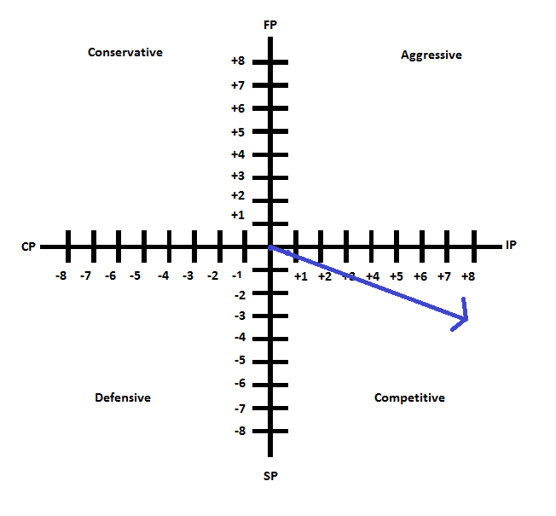

According to the SPACE Matrix, Avon is a firm with major competitive advantages in a high-growth industry. Avon certainly does have several competitive advantages over its peers although I wouldn’t necessarily agree that the industry is that high-growth. The SPACE matrix revealed that Avon holds a strong competitive position.

**IE Matrix**

The IE Matrix positions an organization’s various divisions in a nine-cell display. Avon has a weighted IFE score of 3.22 and a weighted EFE score of 2.78. With these scores Avon falls into the Grow and build category, which is the medium/strong category. This division is focused on different types of integration, market penetration, market development, and product development.

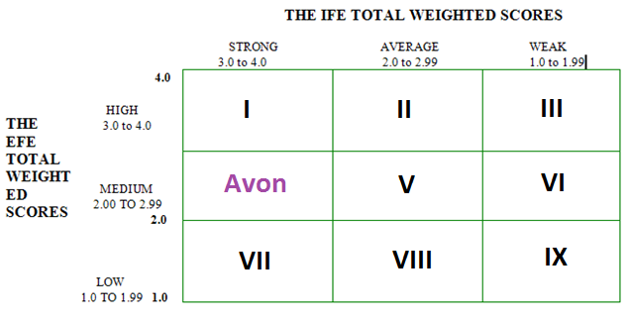

**Conclusion**

Avon Products Inc. has been in the news a lot recently for some positive, but mostly negative headlines. Financially, the company is still turning a profit, however its net income has been sliding lately and the company actually lost money during the fourth quarter of 2011. Its stock price has remained relatively stable while company is experiencing a major management overhaul with the appointment of the new CEO, Sherilyn McCoy. Some of its major issues are its dwindling revenue in North America markets, its declining number of representatives, and its shrinking net income. The company is generating more revenue each year which is a terrific, but with the bottom line dropping fast, it needs to assess where it can cut costs. One possibility would be to stop paying dividends for a few quarters, which although it will be seen as a weakness to investors, it would keep cash on hand for the company to pay advertising costs associated with recruiting more Avon ladies. The Avon representatives make the profits, and with those numbers shrinking it could be bad news for the company. The economy is improving, which should allow more consumers have more disposable income to purchase beauty products. Another issue for Avon is its bribery scandal which the company needs desperately to wrap up and keep out of the news. Avon’s image and stock has been damaged by these investigations so it’s up to McCoy to shed some new light on this organization.

**References**

http://www.enquirer.com/editions/2001/09/16/fin_mary_kay_cosmetics.html

http://today.msnbc.msn.com/id/46761188/ns/today-money/t/avon-ladies-see-need-company-makeover/#.T5DrY6tYvng

http://www.saleschase.com/blog/marketing/the-best-of-avons-marketing-strategies/

http://itdecs.com/2011/12/an-insider-view-of-avons-erp-troubles-in-brazil/

http://www.reuters.com/finance/stocks/overview?symbol=AVP

http://www.marketwatch.com/story/avon-slumps-on-result-sec-investigations-2011-10-27

http://www.thestreet.com/r/ratings/reports/analysis/AVP.html

http://finapps.forbes.com/finapps/BuyHoldSellAnalysis.do?tkr=AVP

http://seekingalpha.com/article/504681-avon-fairly-valued-so-consider-these-other-hot-consumer-stocks?source=yahoo

http://www.reuters.com/article/2012/04/10/us-avon-idUSBRE8380AV20120410?type=companyNews

http://www.worldofdirectselling.com/?p=1575

http://www.avoncompany.com/aboutavon/index.html

http://www.avonfoundation.org/

http://www.reuters.com/article/2012/04/16/us-avon-coty-idUSBRE83F0FY20120416?type=companyNews

**Log**

1. February 14 – First meeting to discuss company and separate work between members.  
2. February 21 – General review of progress  
3. February 22 – General review of progress  
4. February 29 – General review of progress  
5. March 26 – Discussion of history/overview of company  
6. March 29 – Review of models  
7. April 3 – Review of financials/rivals  
8. April 4 – Management discussion  
9. April 5 – General review of progress  
10. April 9 – General review of progress  
11. April 18 – PowerPoints discussion  
12. April 16 – General review of progress  
13. April 17 – PowerPoints review  
14. April 18 – Concluding review  
15. April 19 – Finishing touches